Retail Sales Data Entry & Pivot Table Dashboard
Made By:
Akifah Khatoon

Objective:
To analyze retail sales data and create an interactive dashboard using pivot tables for better decision-making.

Dataset:
Retail sales dataset containing product details, sales amount, quantity, category, and region.

Description:
This project includes data entry, formatting using paint cells, and creation of pivot tables to summarize sales insights. A dashboard is developed using pivot charts to visualize key metrics like total sales, category-wise performance, and regional analysis.

Tools Used:
- Paint Cells (Excel Formatting)
- Data Entry
- Pivot Table
- Pivot Dashboard

Dataset:
Retail Sales Dataset containing product-wise sales, quantity, category, region, and date information used for analysis.
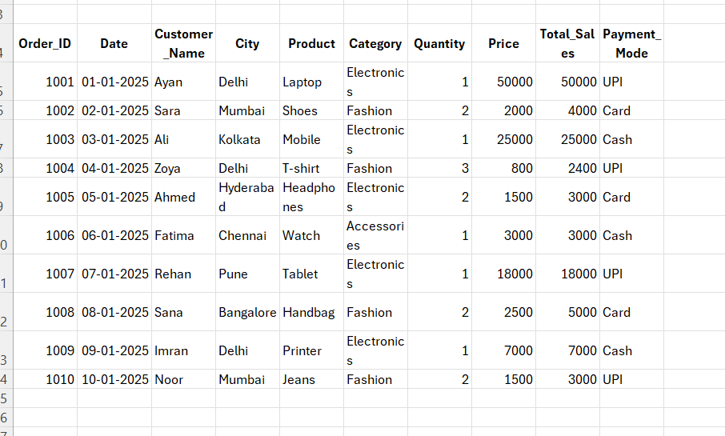

Pivot Table – 1
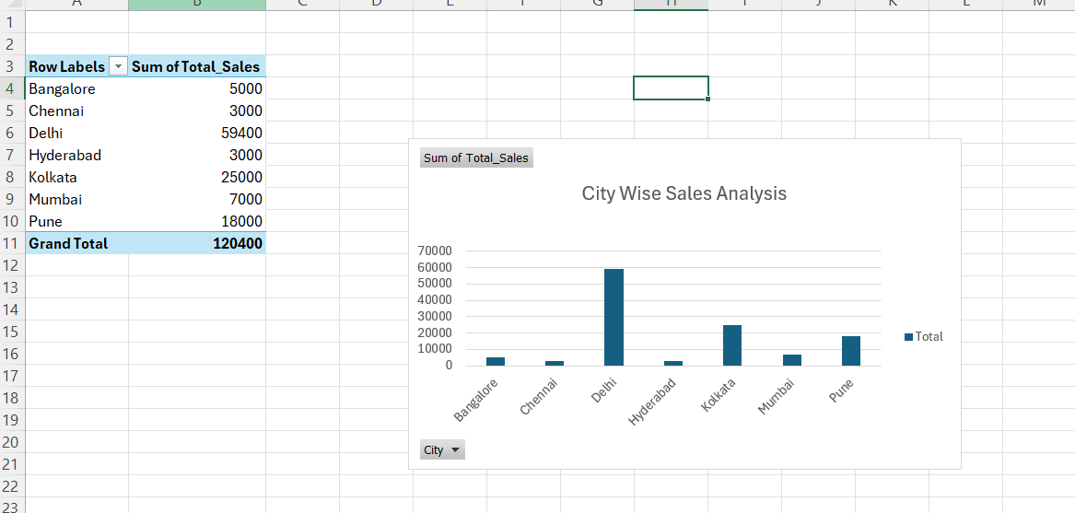

Pivot Table – 2
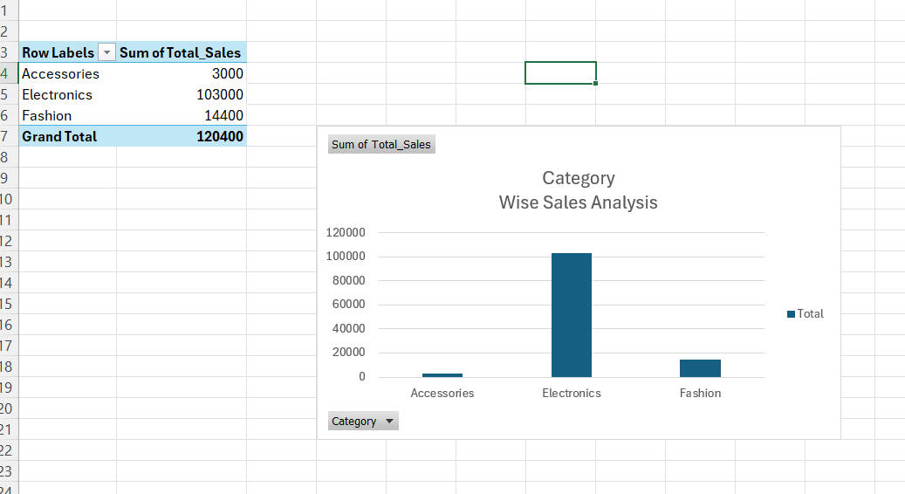

Pivot Table – 3
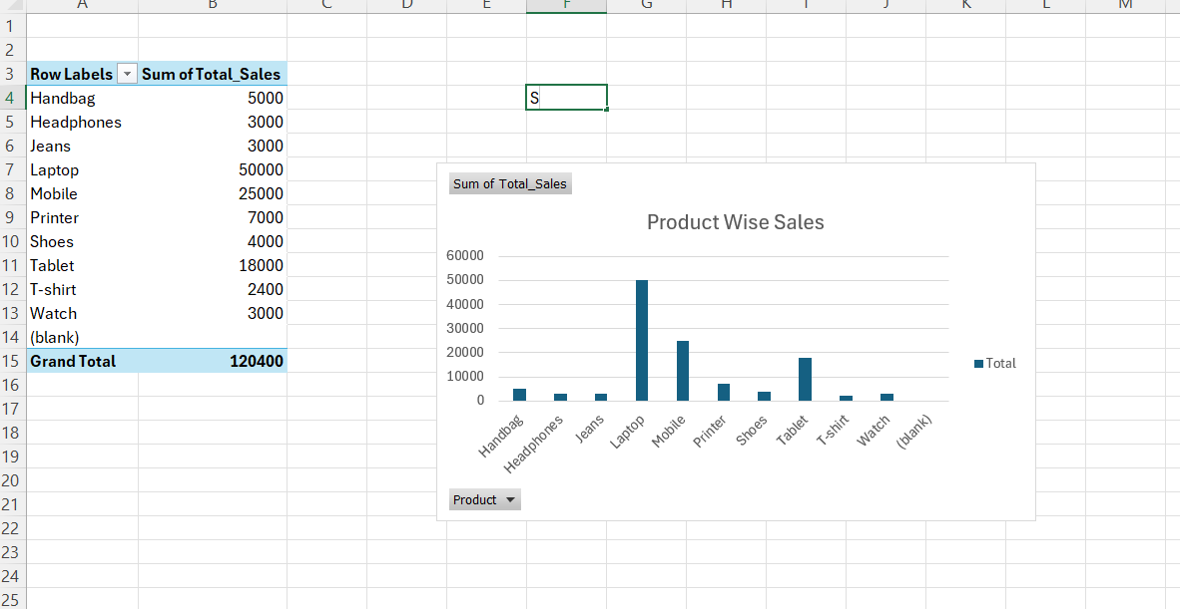

Conclusion:
This project helped in understanding retail sales data by organizing, analyzing, and visualizing it using pivot tables and dashboards. It improved data entry, formatting, and analytical skills, and provided clear insights into sales performance across different categories and regions.
Thank You.

